

**WE WOULD LOVE TO HEAR FROM YOU**

We want to make it easier for you to reach us. That’s why now, as well as calling us, you can send us a ‘***HELLO’*** message on WhatsApp! This way it is easier to stay in touch, enquire about appointments and our services will only be a message away. Add us on WhatsApp using our number **01858 464242.**

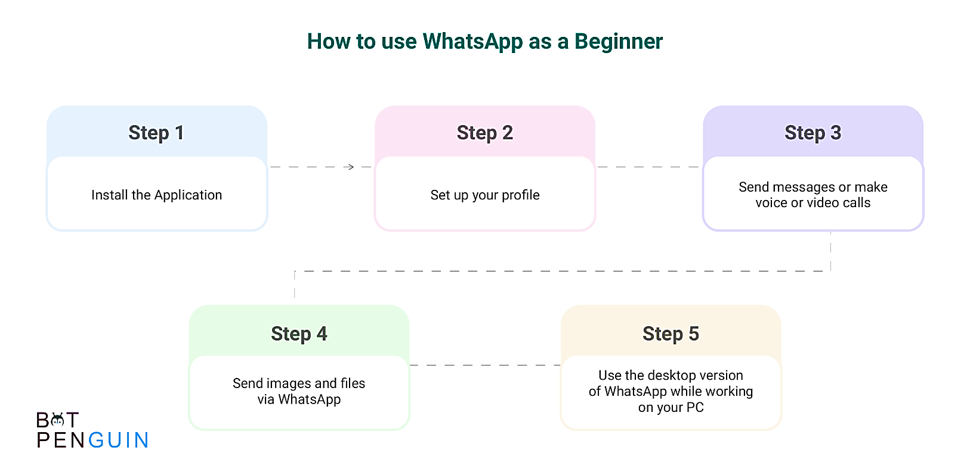

Send us a message!

Follow the step-by-step instructions to help get you set up and ready to use our WhatsApp services.

1. Head over to the Apple store for iPhones, or the Play store if you have an android mobile. These will look similar to the symbols shown below.

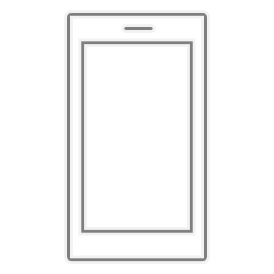

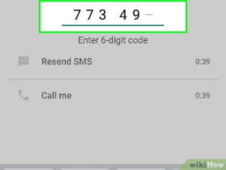

**2.** Search for ‘**WhatsApp’** in the search bar of the app store. This should direct you to the app page where you can install the app onto your mobile device.

**3.** Once installed click on ‘**agree and continue**’, to the terms and conditions. You will then be asked to input your country and link your mobile number to WhatsApp. Selecting ‘**United Kingdom**’ and input your numbers after **+44**.

**4.** You will be sent a **6-digit** verification code to input into the app.



**5.** Once your phone number is verified you will be able to begin a new message directed at the Market Harborough medical centre. Just ensure that our number is saved to your contacts!

**6.** Finally, drop us a message saying ‘**HELLO**’ and we will send over a triage form for you to fill out and kick-start the process of answering any of your queries or concerns.

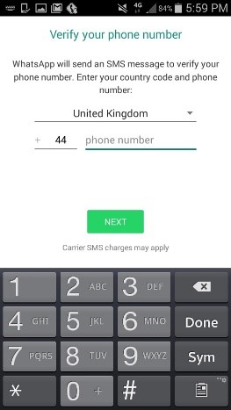



Once you are all set up, you will have ease of access to our services and can rest assured, knowing that you can get in touch directly, with just a message.

Here at the medical centre, our clinical triage team look forward to greeting you with a smile and taking care of you in the best way we can.

We look forward to hearing from you and welcoming you in the New Year!





